C:\Users\Yu\AppData\Roaming\Tencent\QQ\Temp\%W@GJ$ACOF(TYDYECOKVDYB.pnghttps://www.linkedin.com/in/qi-zhuang-a0aa4221/

Intepoch: 开发用户界面(UI)

What is unity 3D:

What did I debugged:

Use OpenCV/library:

Filter

Segmentation

Foreground

background

Shape detection

Trigger an Event / an event will occur / call back function 🡪 get the input🡪 use grabcut to find where is the hair🡪save to a vector.

Event 🡪 🡪 get the input

button

Dropdown list:

Color

Hair style

The original picture is saved in a vector,

My manager did the main pare, I first learned the how project, and then focused on I worked event handler part, how to change the color and the style of the hair, and some debugging!

Machine learning project:

What is CNN network:

Use the (CNN network) tensorFlow and the python to do the training, get some picture, set to the same size, then label them, let the tensorflow to train the image (image vector). It will get a matrix, after the training, the picture will use the matrix to the image beyond to which label. Then will have output bp file, and send bp file and my lable txt file to android. Use java to handle the event and use c+ + to write the function.

*The project contains two parts: the first part is the Android App Project with the fruit grading App, the second part is the Python Project with the TensorFlow model training.*

*A describing how code is structured and the state of how it works. Give a description for each filename listed.*

* In Android Project: The whole project is based on Google’s TensorFlow Android example. The main source files are ClassifierActivity.java and TensorFlowImageClassifier.java; the main model files are mytest.pb and mylabel.txt.
  + ClassifierActivity.java: Activity class. Initialized the tensorflow utility. Communicate with tensorflow utility. Handle result with TTS engine.
  + TensorFlowImageClassifier.java: the tensorflow utility. Communicate with the real tensorflow library. Prepare data and get result from the tensorflow library.
  + mytest.pb: model file used for tensorflow library.
  + mylabel.txt: dictionary file to translate number to the label.
* In Python Project: The training part is based on the TensorFlow example MNIST at <https://www.tensorflow.org/get_started/mnist/pros> . The banana images are from <http://image-net.org/> . There are two main source files in the project: TrainerFruitGrade.py and two_layer_fc.py.
  + TrainerFruitGrade.py: load images, build the network, save models.
  + Two_layer_fc.py: implementation of the layers for the neural network.

AI(artificial intelligence) // find all the possibilities, until get the destination / meet your goal, choose the best one.

NetLogo: use AI to catch the most fish

The goal of the project is to catch the most fish. (more details on fishingBoatExplain.docx)

1. The boat has a limit of 20 ticks or steps per trip and at the end, it must be back to the port.

2. Moving 1 patch will be counted as 1 tick and catch a fish will use 1 tick.

3. This “world” is a 5 by 5 grid with (0,0) at the bottom left corner.

4. The number on the right part of pairs on the game screen is a reading number, and this number will not change if fish decrease. It is random number from 1-100.

5. The really number of fish will be the random number from 0 to reading number. As you can see for this game, the first part of pair numbers is less than the right part.

6. If fish are more than 10, just use 1 tick to catch 10 fish, if fish are less than 10, then fish all, and move to the next patch.

7. The boat will use radius to find the closest patches and to check if the reading number is more than 10 if more than 10, then catch the fish, otherwise, move to the next patch. At the meantime, it keeps track the number of total fish and the ticks. Need to save enough ticks to go back to the port.

8. The game shows total number of fish it has caught;

9. the fish has caught at each patch;

10. and the reader list where have the record showing the reading fish if the boat has been there before.

11. Each trip will catch the most fish.

Gecode:

It is also a library, there are many functions to deal with constrain;

Class schedule: sections, time, room course department. one section of each course

‘’’Gecode have the function to check the classroom, the time which section and which instruction do not have the constraint conflict. The output all the possibilities.

This project used A* algorithm to play the game.

This game has starting-level from 1 to 20. Level 1 have 5 point, and there are lines cross each other, this game with A star algorithm to move the point and at the end of game, there will no lines cross each other.

H value(heuristic): distance from a node to a target node

G value(move cost):G value of parents plus the movement cost to a node.

Parent:

List:

Open list

Close list

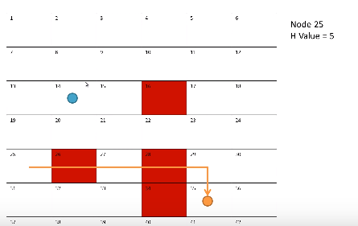

G value(move cost):G value of parents plus the movement cost to a node.

F value: G + H

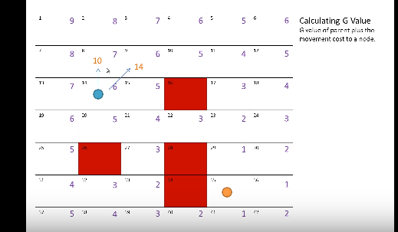

F value: G + H

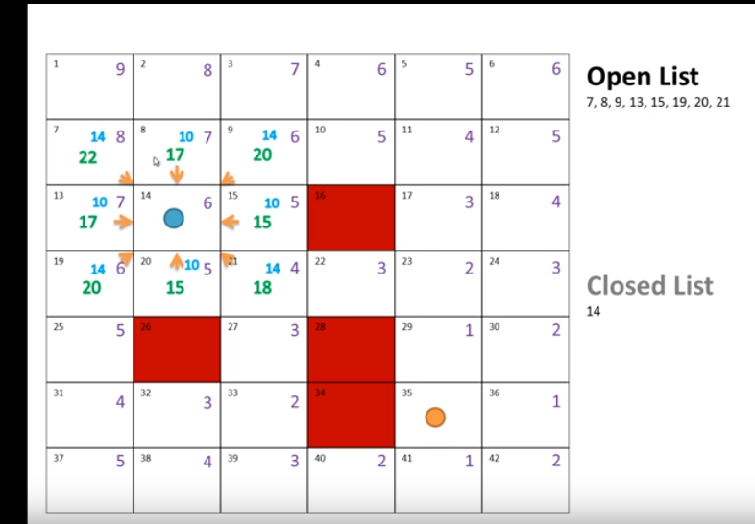

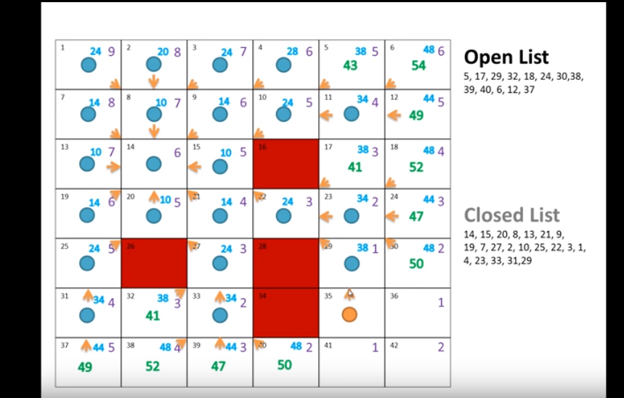

Parent:

List:

Open list

Close list